New Loop
Policy Architecture and simulator

This paper details the policy architecture of the New Loop model in macroeconomic and institutional terms. These mechanisms are certainly not the only possible response to the transition, but the model shows, policy by policy, how a market economy can remain socially and financially stable when advanced automation weakens the old wage driven demand loop.
For an easily readable narrative description of the New Loop, please see the companion paper, The New Loop: A Future History of the AI Transition. Another paper, Claude Critique of the New Loop Scenario is also available. It includes some relevant literature references.
The problem the New Loop addresses is straightforward. As machine intelligence raises output while reducing the role of labor in production, wage income becomes a weaker channel for distributing purchasing power. Without compensating institutions, the result is not a smooth transition into abundance. The economy instead drifts toward weak demand, debt stress, political backlash, and repeated attempts to restore the old system after its economic base has already begun to erode.
The policies below are therefore designed as a rule based stabilizing architecture. Taken together, they aim to preserve purchasing power, broaden ownership, prevent debt deflation, and keep private investment attractive even as the composition of income changes. Each section answers three questions: what problem the policy addresses, how it operates, and why it helps stabilize the transition.
After discussing the policies in detail, the paper presents a guided, illustrated tour of the outputs from a sample run of the New Loop simulator app.
Roger Ison
roger@miximum.info

1. Public Trust Fund
The Social Wealth Trust broadens equity ownership. Its purpose is to ensure that as production becomes more automated, households gain an expanding claim on the resulting surplus, rather than relying primarily on wages that no longer rise in proportion to output.
The Trust activates when household debt-service stress rises to a level indicating that the legacy distribution system is no longer keeping enough households solvent. This trigger ties the Trust to observable strain in the household balance sheet, rather than presenting it as an ideologically motivated or confiscatory institution.

1.1 Optional leveraged launch
At activation, the Trust can begin gradually, or it can be jump-started with bank-created credit. In a jump-start, the Trust acquires an initial block of equity from the household sector, immediately increasing society’s income-bearing claim on productive assets.
This borrowing is not intended to create permanent leverage. It is designed to be repaid as quickly as practicable from subsequent Trust income. The purpose is transitional: to accelerate broad ownership at the moment the economy is already showing debt stress.

1.2 Ongoing accumulation with an explicit cap
After activation, the Trust can continue to build its position through the issuance of new shares allocated to the Trust. This increases broad ownership through gradual dilution over years, rather than through seizure of existing private holdings.

An explicit ownership cap is essential. The cap signals that the system remains a mixed economy rather than a nationalization regime, preserves the incentive and valuation structure of private equity, and gives investors a clear boundary within which private ownership continues to dominate.

1.3 Debt first treatment
If the Trust begins with borrowed funds, any cash it receives is applied first to retire that debt before being used for broader transfers. This makes leverage temporary and disciplined. The Trust may borrow to establish itself, but it is not designed to operate as an indefinitely leveraged public holding company.

1.4 Residual balances
Once the Trust is operating, a further design choice concerns the treatment of any residual cash balances. Those balances can be retained within the Trust for the long-term benefit of citizens, or a portion can be made available to the government as an additional fiscal buffer.

2. Universal Basic Income
Universal Basic Income is the New Loop’s principal purchasing-power stabilizer. Its purpose is to maintain a dependable floor under mass consumption when labor income becomes less adequate as the main channel through which households share in production. It is not intended to abolish work or eliminate income differences.

2.1 Real income target
The income floor is defined in real rather than nominal terms. This distinction matters because a society can appear to be distributing more money even while actual purchasing power declines. By tying the target to real purchasing power, the system helps preserve the capacity to consume real output rather than merely preserving the appearance of support.

2.2 Non-decreasing ratchet
Once the basic income rises in real terms, it is not allowed to fall. This ratchet reflects an institutional reality: once a society has acknowledged that a certain level of support is necessary to prevent a collapse in living standards, abrupt reversals become both economically destabilizing and politically implausible. The ratchet therefore represents policy commitment, not generosity for its own sake.

2.3 Funding hierarchy
Funding follows a layered order. A modest portion of Universal Basic Income support comes directly from monetary issuance, which can be appropriate and non-dangerous in a deflationary economy. After that, available balances in the Social Wealth Trust and in government-received accounts are drawn down before additional issuance serves as the residual backstop.
This hierarchy avoids unnecessary monetary expansion when non-inflationary funding sources are already available, while still ensuring that the income floor does not fail for lack of accounting balances.

3. Value Added Tax and Low-Income Credit
The value-added tax is the broad revenue instrument of the architecture. In an economy where labor compensation may no longer be the main source of taxable income, a tax linked to consumption becomes more important because it captures revenue from economic activity regardless of whether that activity is generated by human labor, capital-intensive production, or highly automated firms.

3.1 Role of the tax
The tax creates a wedge between producer prices and consumer prices. In practical terms, it allows the public sector to reclaim part of the surplus generated in the automated economy at the point of consumption. It therefore complements income and profit taxes rather than replacing them.

3.2 Low income credit
Because a broad consumption tax can be regressive if left on its own, the system pairs it with a targeted credit for lower income households. The credit is intended to offset the burden of the tax on essential consumption at the lower end of the income distribution. This preserves the revenue power of the tax while preventing it from pushing already vulnerable households deeper into distress.

3.3 Funding rule
The low-income credit is treated as guaranteed. When ordinary government balances are sufficient, they fund it directly. When they are not, the remaining amount can be completed through issuance. The point is that compensation for regressivity is not optional once the tax exists. It is part of the tax design itself.

4. Income Tax Design
The income tax remains part of the architecture, but in simplified form. Its purpose is not to carry the entire fiscal burden of the transition, since the wage-linked tax base may weaken over time. Instead, it continues to perform familiar redistributive and revenue-raising roles while operating alongside broader consumption- and profit-based instruments.

4.1 Tax base
The tax applies to market income, such as wages and dividends, but not to the Universal Basic Income transfer itself. Basic income is treated as a social floor rather than as taxable earned income. This prevents the system from clawing back the support mechanism through the ordinary income-tax base.

4.2 Simplified Progressive structure
The structure is deliberately simple. Income below a moving threshold is untaxed, while income above that threshold faces a flat marginal rate. Because the threshold is defined relative to the income distribution rather than as a fixed nominal figure, the progressivity of the system adjusts as the economy changes.
This design is easy to understand and difficult to evade. It also reflects a minimal and transparent definition of fairness: everyone is treated the same under the rule, but the rule exempts a defined lower portion of the distribution.

5. Corporate Income Tax
As automation shifts a larger share of revenue toward capital reinvestment and profits, the corporate tax becomes a more important stabilizing instrument. It is one of the main channels through which the public sector participates in the surplus generated by highly productive firms.

5.1 Broad profit base
Profits distributed to shareholders as dividends are not taxed at the corporate level. This encourages dividend payouts and makes taxation more transparent at the household level.
Retained earnings are taxed before reinvestment. Capital investment remains deductible through depreciation, taken over a standard ten-year period. The goal is to tax the corporate surplus broadly while still recognizing long-lived investment through predictable depreciation.

5.2 Automatic adjustment as labor income declines
The corporate tax rate can rise automatically as wage payments fall relative to a historical baseline. This makes the tax a structural stabilizer: as labor ceases to carry as much of the distributional burden, capital is asked to carry more of it.
Boundaries on the adjustment range are important so that firms remain investable and the tax does not become politically or financially erratic. In practice, the corporate tax rate is indexed to the decline of total wages in the economy, but it is also clamped within explicit minimum and maximum rates. This indexing is not punitive. It is an automatic rebalancing as the labor-capital balance shifts, while the clamps help keep the corporate sector investable.

6. Government Surplus Recycling
This mechanism prevents the public sector from becoming a passive sink for purchasing power. If the government ends a period with large residual balances after its obligations have been met, it may return part of that surplus to households.

6.1 Rebate logic
The rebate can be structured in different ways, but the underlying principle is simple: idle public balances should not accumulate mechanically once they are no longer needed for stabilization. Returning part of that surplus helps sustain circulation and prevents the architecture from becoming contractionary for no designed reason.

7. Monetary and Credit Regime
The architecture assumes a credit regime aimed at preventing temporary liquidity strain from turning into a cumulative collapse of demand. These rules are stylized, but they express an institutional principle: in a transition defined by structural redistribution problems, the system should not magnify ordinary cash-flow shortfalls into mass default cascades.

7.1 Unified loan rate
For simplicity, the model uses a common loan rate across the relevant forms of credit. This is not a literal institutional proposal. It is a simplifying assumption that lets the model focus on the larger transition dynamics rather than on the microstructure of differentiated lending markets.

7.2 Household deleveraging order
When households have enough cash flow to reduce debt, they do so in a fixed order. Short-term revolving debt is paid down before mortgage debt. This reflects the practical reality that high cost short term liabilities usually create the most immediate pressure on household stability.

7.3 No hard default through overdraft conversion
If a household would otherwise fall below zero in deposits, the shortfall is converted into revolving debt rather than triggering immediate default. In other words, temporary cash flow failure is treated first as a credit event rather than as a terminal balance sheet event. This prevents localized liquidity stress from producing a chain reaction of collapsing consumption, forced asset sales, and bank losses. It is, however, a modeling device rather than a literal institutional proposal.

7.4 Mortgage indexation as deflation stabilization
A highly automated economy is likely to produce structural deflation. For current consumption this can look benign or even welcome, because many goods become cheaper. For long term nominal debt, however, deflation is dangerous. Fixed nominal mortgage payments grow heavier in real terms as prices and wages fall. Households then cut consumption in order to service debts whose burden has effectively risen, and the economy can slide into a classic Fisher debt-deflation spiral.
A second danger is lock in. If home prices fall while mortgage balances remain fixed in nominal terms, households can become trapped underwater. They cannot sell, move, refinance, or adapt to changing labor markets without realizing losses they cannot absorb. That makes the housing system rigid at precisely the moment when flexibility is most needed.

7.4.1 Hybrid index and lender neutralization
The proposed response adjusts required mortgage payments downward in line with a blended index of prices and household income. The index is hybrid because debt distress depends on both the general price level and the actual income flow available to households. Tying payments to this blended index strips out the deflationary penalty that would otherwise be embedded in legacy nominal contracts.
At the same time, the model does not simply force lenders to absorb the full gap between the original contractual payment and the indexed payment. That gap is treated as a macroeconomic stabilization cost. The public sector covers it directly, using monetary issuance if necessary. This neutralization step allows the household side of the contract to be eased without damaging bank balance sheets or the fixed-income asset base on which much of the financial system rests.

7.4.2 Why this mechanism matters
In ordinary political language, support for lenders is often framed as a bailout of capital at the expense of labor. Here the logic is different. In a successful automation transition, preserving the financial system is part of preserving the productive and credit infrastructure through which the new economy must still operate. If households are crushed by legacy debt, demand collapses. If banks are crushed by forced write-downs, credit collapses.
Mortgage indexation with lender neutralization is designed to prevent both failures at once while remaining politically and economically fair to both sides of the lending contract. The public sector stabilizes the system; it does not “bail out” banks or households.

7.4.3 Construction of the index
The index is updated regularly as a geometric blend of two movements: the change in the price level and the change in nominal household income. The relative weight placed on each component determines whether the system emphasizes macroeconomic prices, household cash flow, or a compromise between the two.
A pure price index would not fully capture distributional change. A pure income index could become too contingent on short-run labor-market noise. The blended approach is more robust across both dimensions.

7.4.4 Payment rule
When the policy is active, required mortgage payments move with the index. The economically sensible implementation is to apply the index to the current contractual payment path rather than to rewrite the entire stock of mortgage principal in a single step. That preserves contractual continuity while still removing the destabilizing effect of deflation on the household cash-flow burden.

7.4.5 Neutralization funding
Whenever indexed payments fall below original contractual payments, the difference is recognized as a stabilization gap. That gap is covered from government resources, including money issuance as a last resort. This preserves the solvency of the credit system while the New Loop is being established.

7.4.6 Accounting treatment
Households continue to make required mortgage payments together with any interest due on revolving balances. Mortgage payments still flow first to interest and then to principal. Lenders receive the indexed household payment plus any neutralization transfer. The model records government “make-whole” support transparently as a stabilization outlay.

8. Wage Structure Under Automation
The model treats wages as a share of sectoral revenue that falls as automation becomes more effective. This is not a policy in the ordinary sense. It is the structural fact that makes the rest of the architecture necessary. Without a weakening wage channel, many of the stabilizers above would be far less urgent.

9. Price Formation Under Automation
Prices are shaped by two opposing forces. Productivity improvements push prices downward by lowering the real cost of production, while increased market power or markup capture can push them upward. The model therefore allows automation to generate either stronger disinflation or stronger profit capture, depending on institutional conditions. That matters because the required scale of stabilization depends not only on how much labor is displaced and how much capital is reinvested, but also on how much of the productivity gain is passed through to society in lower prices.

Closing Perspective
Taken together, these policies form an integrated transition architecture rather than a menu of unrelated programs. The Social Wealth Trust broadens ownership. Universal Basic Income maintains a floor under mass purchasing power. The value-added tax and indexed corporate tax reclaim part of the surplus generated in the automated economy. The low-income credit prevents the consumption tax from becoming regressive. Surplus recycling keeps public balances from becoming inert. The credit regime prevents temporary cash-flow failures from cascading into systemic collapse. Mortgage indexation prevents legacy nominal debt from turning structural deflation into social and financial breakdown.
It is also important to note that this architecture is strongly pro-investment and pro-capital. Corporations remain able, and are positively encouraged, to grow through rising productivity, while demand can grow alongside them. Society becomes wealthier under such a system, and the Social Wealth Trust grows with it.
The larger purpose is neither to replace capitalism with command allocation nor to preserve the existing wage-centered order unchanged. It is to keep a market economy investable, solvent, and politically legitimate under conditions in which the old distribution loop no longer performs enough of that work on its own. In that sense, the architecture is best understood as a set of institutional bridges from one form of capitalism to another.

New Loop Simulator and Outputs
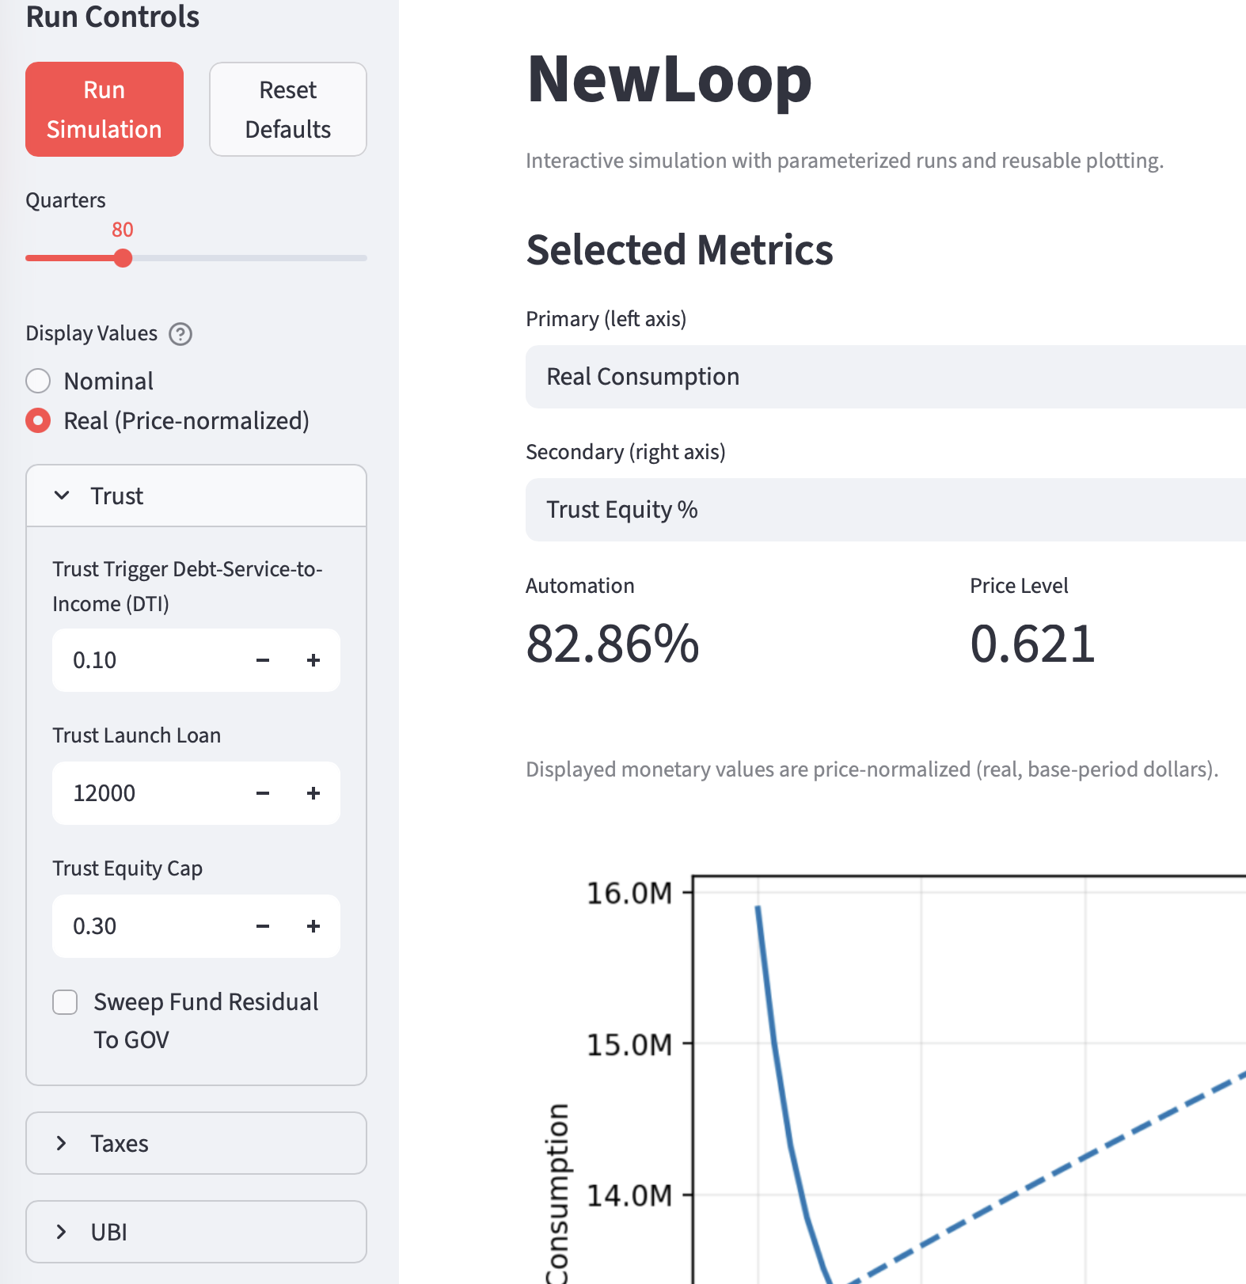
New Loop is written in Python, and its structure is therefore easy to inspect by any reader who wishes to examine it directly. It is, however, a fairly detailed model, with many parameters that can be changed to observe their consequences. The purpose of this section is to illustrate what can be learned by running the model, and to emphasize that the code implements the same mechanisms described in the policy discussion above.
The partial screen capture at right illustrates that the app offers drop-down lists in a sidebar so users can change the default parameter values for a simulated run. The parameters are categorized: Trust, Taxes, UBI, Automation, Price & Capital, Population. In the Trust parameters, for instance, it might be interesting to change the size of the Launch Loan, or eliminate it altogether. In addition to many data plots, the entire quarterly stream of data generated by a simulation run is captured for inspection in a scrollable table.
New Loop is a stock-flow-consistent model. “Stocks” in this context are reservoirs of money or value connected by cash flows. Money flowing out of one reservoir must flow into another, with corresponding debits and credits, and reservoirs can become temporarily negative, representing debt or deficits.
Because the story told here is about the production-wages-consumption loop, it is essential that all cash flows into and out of the model’s nodes add up. For readers with an engineering background, this is directly analogous to Kirchhoff’s law governing electrical current flows. New Loop does not have any hidden or gratuitous cash flows to bias the results. The code is instrumented to verify that these flows remain fully consistent.
New Loop creates an initial population of 20,000 households whose incomes, invested wealth, revolving debts, and mortgages roughly parallel the proportions of those in the current United States population. Lower-income households, for example, carry more revolving debt relative to net worth. A marginal-propensity-to-consume structure is discretized over five quintiles of the population. Households are generated from a statistical distribution rather than imported from raw microdata, though that part of the code could readily be replaced with a module that reads actual household data.
Mortgages and revolving debt are the only debt instruments modeled in New Loop. Bonds are not included. That is a limitation, but probably a less serious one than it might first appear. In a real economy, bonds and equity are both reservoirs of value, though with different characteristic behaviors, and investors shift capital between them as the risk environment changes. Real estate, for example, is largely representable as either mortgage debt in the household sector or bond-financed structures in the commercial sector. Apart from the special effect of deflation on debt contracts, bonds are probably not central to the present model; and the treatment of mortgage debt demonstrates the relevant policy logic. In a persistently deflationary environment, it is likely that much commercial debt would be renegotiated rather than simply defaulted. Gold is also a surprisingly large store of value, but it is unproductive and therefore not important for the purposes of this model.
The model contains a single Bank. Corporations are represented by an Information-sector company, which adopts automation earlier, faster, and more completely, and a Physical-sector company, which adopts more slowly and ultimately less completely. These adoption paths are represented by longitudinal S-curves spanning the full eighty quarters of simulated time. Government receives taxes and issues money only as the model requires.
The model aims to be realistic where realism matters most. As automation rises, corporate productivity increases and costs decline. New Loop’s parameters govern how much of that gain is captured and reinvested or distributed to shareholders, and how much is passed through into lower prices under competitive pressure.
Mortgage payments are indexed exactly as described in the policy discussion above. The Bank receives the indexed payments, and the Government makes make-whole payments according to the terms of each household’s mortgage.
New Loop is easy to explore through the Streamlit version, which presents the model’s outputs in a web browser. A user can vary parameters and immediately see a collection of graphs showing the economic trajectory of many variables over eighty consecutive quarters. The graphs below illustrate the outputs displayed for a baseline set of parameters.

Automation curves
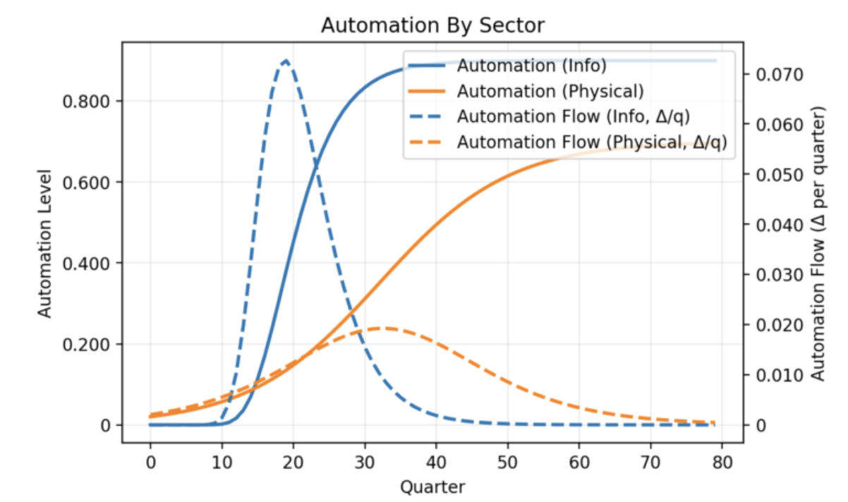
These curves depict intelligent automation adoption in the Information and Physical sectors of the economy over 80 quarters of time. The solid lines show total penetration of labor replacement. Information automation is faster and more complete, stabilizing at about 75% after ten years. Physical sector automation is slower, because it requires developing machinery, training intelligent robots, and so on. It also stabilizes below 60% total penetration after 20 years.
The dotted lines show the derivatives of the automation curves, illustrating the different rates of change in these two sectors.

Population distributions
The next two plots present the income and wealth distributions before the new system is instituted, and at the end of the simulation. These represent real, not nominal, dollars.
The income distributions have a spike at the left, because initially there is a proportion of unemployed households with no income. The “before” state of the model does not reflect existing social security protections. The income distributions show that after 20 years, the minimum support for completely unemployed households is substantial, and the entire population has much higher incomes than before. This reflects both the UBI and the increase in corporate production with automation, since a portion of that is distributed as dividends.
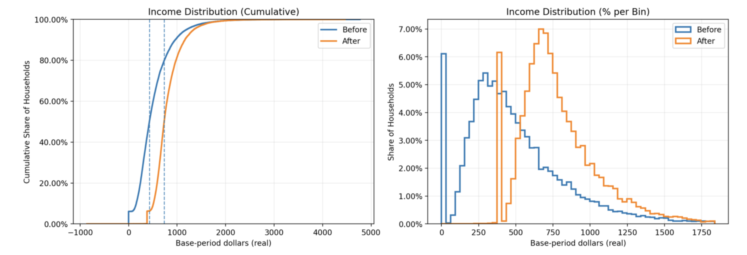
In this model run the trust equity was capped at 30%, which is reached after about 50 quarters. The wealth distributions show that at the 50th percentile (right-hand dotted line) of the right-hand chart below, households are considerably wealthier, in real terms, than they were before. Among the wealthiest household, total wealth is somewhat reduced but not dramatically. This represents two effects: equity dilution, which is a slow and capped wealth tax, but also gain in total wealth over time due to continuing productivity improvements and greater total output.
Although not illustrated here, there is nothing magic about the 30% equity cap. The numbers work out acceptably well at 25%, or at 35%. The policies working together have a broad range of stability.

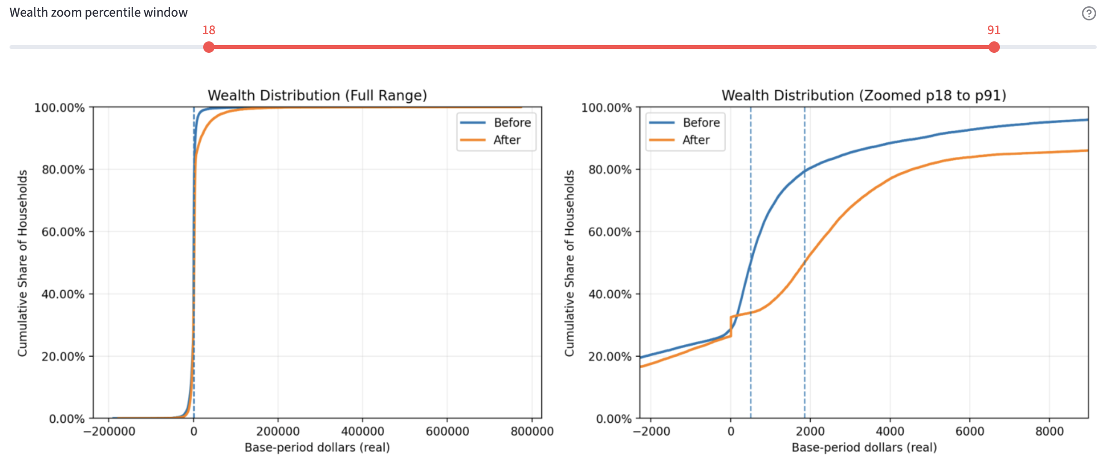

Inequality (Gini metrics)
The wealth distribution might be easier to understand as Gini metrics. New Loop plots three measures of inequality throughout the simulation run. In the plot below, the green line shows wealth inequality among the 20,000 households. The blue line shows household inequality of income before income tax, VAT credit, UBI, and debt service. It is essentially unchanged in real terms over 80 quarters. The orange line shows disposable income inequality after all tax and support transfers.
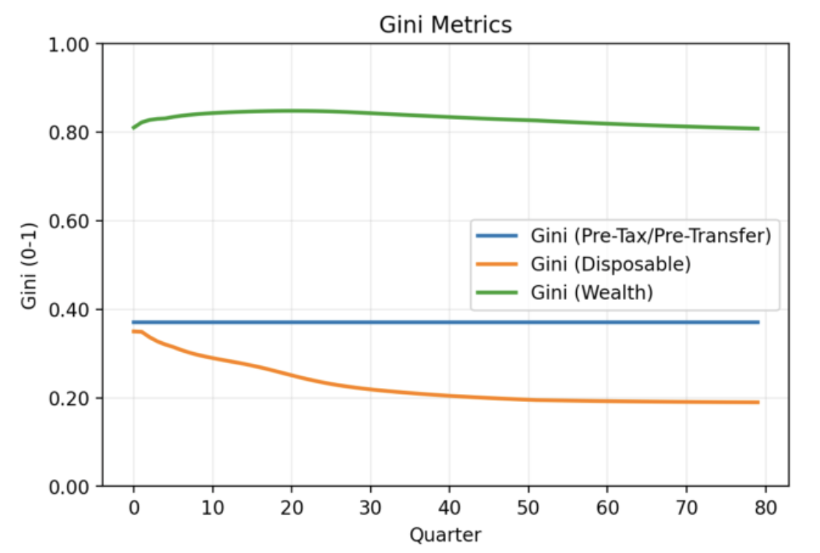
This plot reveals two things. First, the transition policies altogether improve inequality of disposable income. The whole population can actively consume and support the new macroeconomic production - consumption loop.
Second, the green wealth line shows that households that were wealthy before the automation transition remain so after it. There has been some shift, as the zoomed Wealth Distribution plot show, above. But the hierarchy of wealth in the population has not changed very much. The wealthy have not really been hurt.
This is important: it shows that the proposed policies demonstrably do not play out as a socialist or confiscatory regime. The New Loop is still a capitalist society. Entrepreneurs and investors can still reap big rewards. In fact, the UBI and other policies make it safer to take financial risks and create innovations.

UBI and real household outcomes
The UBI funding mix ought to show substantial contributions from tax take, trust fund distributions, and government issuance, and it does. The left-hand plot shows per-household UBI distributions growing steadily for about 30 quarters, then beginning to slowly level off. UBI from the trust fund grows until Q50, when the equity cap is reached. Tax contribution widens continuously, reflecting both increased output from reinvestment, and VAT.
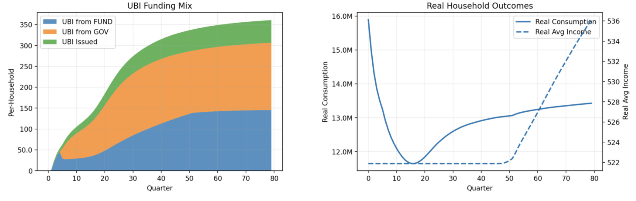
The left-hand plot also shows UBI Issued as a small but slowly growing amount of real dollars. This reflects two intentional policy choice in the model. UBI is not allowed to decrease, only increase, even if the government must issue money to fulfill the commitment. A little money issuance is inflation-safe and lubricates the system, because the economy is in a persistent deflationary state.
This can be seen in real average income (dotted line, right-hand plot), and real consumption. The flat regime is the clamped UBI (never allowed to decrease). After 50 quarters it rises steadily and at a pretty good clip. Real consumption falls at first, as the policies take time to work. But then it rises. This is governed mainly by parameters that control how much of reduced cost and increased output are allowed to flow into price reductions, versus being captured as more corporate profit and either reinvested or distributed as dividends.

The model reveals serious stresses during the transition
Despite the policy backstops, this transition will not be painless. An advantage of modeling is that everyone who is interested can have a sense of what might be coming, and plan for it or perhaps adapt the policies a bit. For instance:
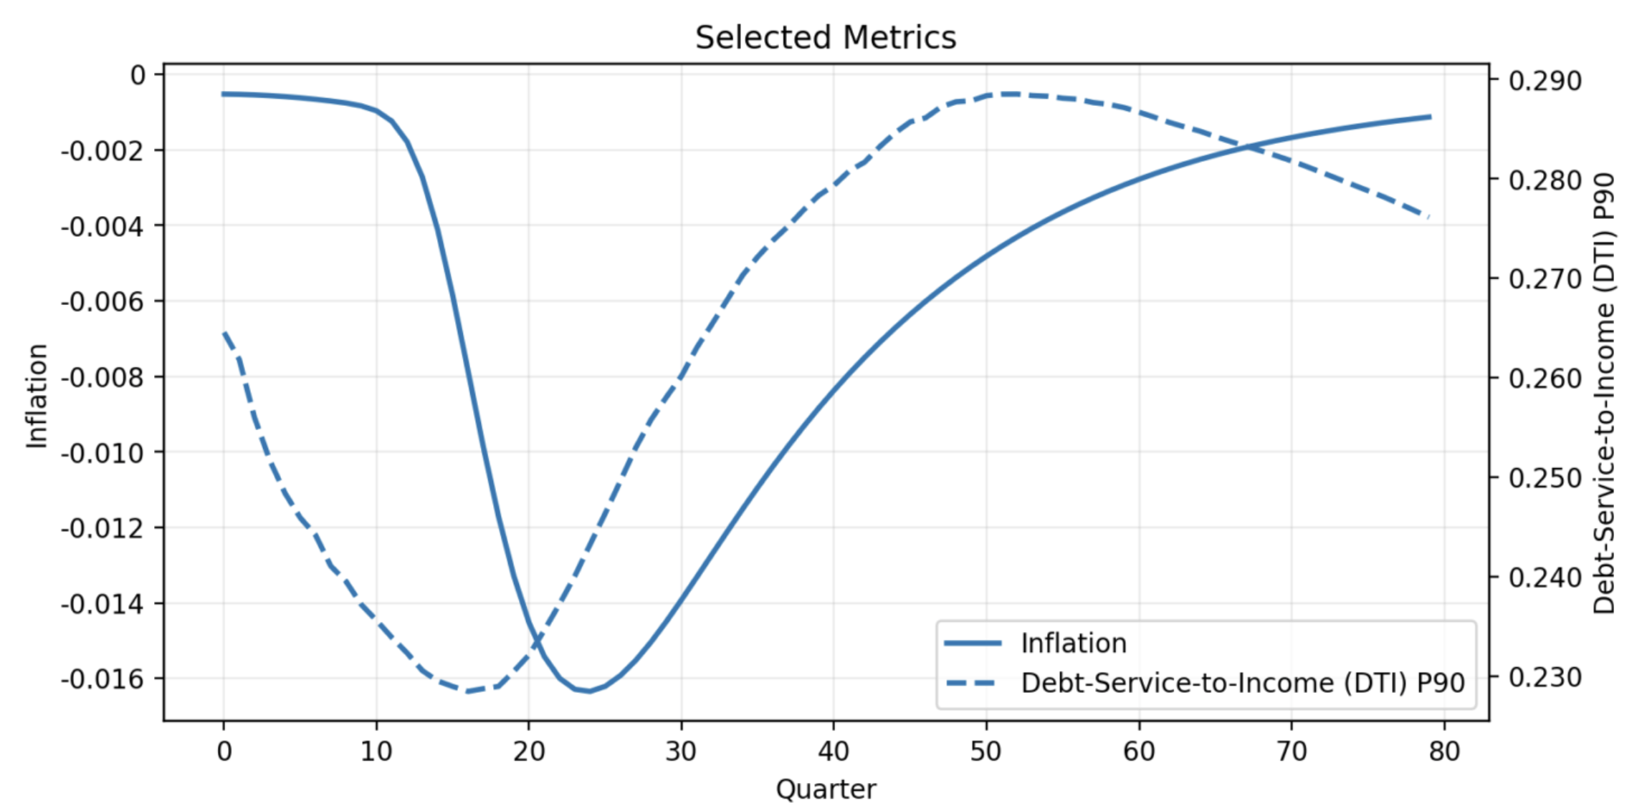
The solid line traces the deflation process, with (negative) inflation on the right-hand Y-axis. Prices fall steeply as the automation adoption process plays out, but after Q25 things turn around. After 20 years, deflation has pretty much ended.
Under the policies, while UBI is never allowed to decline, indexed mortgage payments shrink with deflation, and government makes up the difference to the bank. The consequences for households appear in the Debt-Service-to-Income (DTI) dotted line, which is plotted to include households up to the 90th percentile (P90). Because mortgage payments are indexed to deflation, debt service rises as a fraction of income when deflation starts working itself out of the system and consumption grows. After 20 years, deflation is over, real incomes are rising, and DTI begins to fall. It would continue falling if we ran the simulation for more than 80 quarters.

The parameters associated with the policies introduced in this paper are explained in a separate document.

